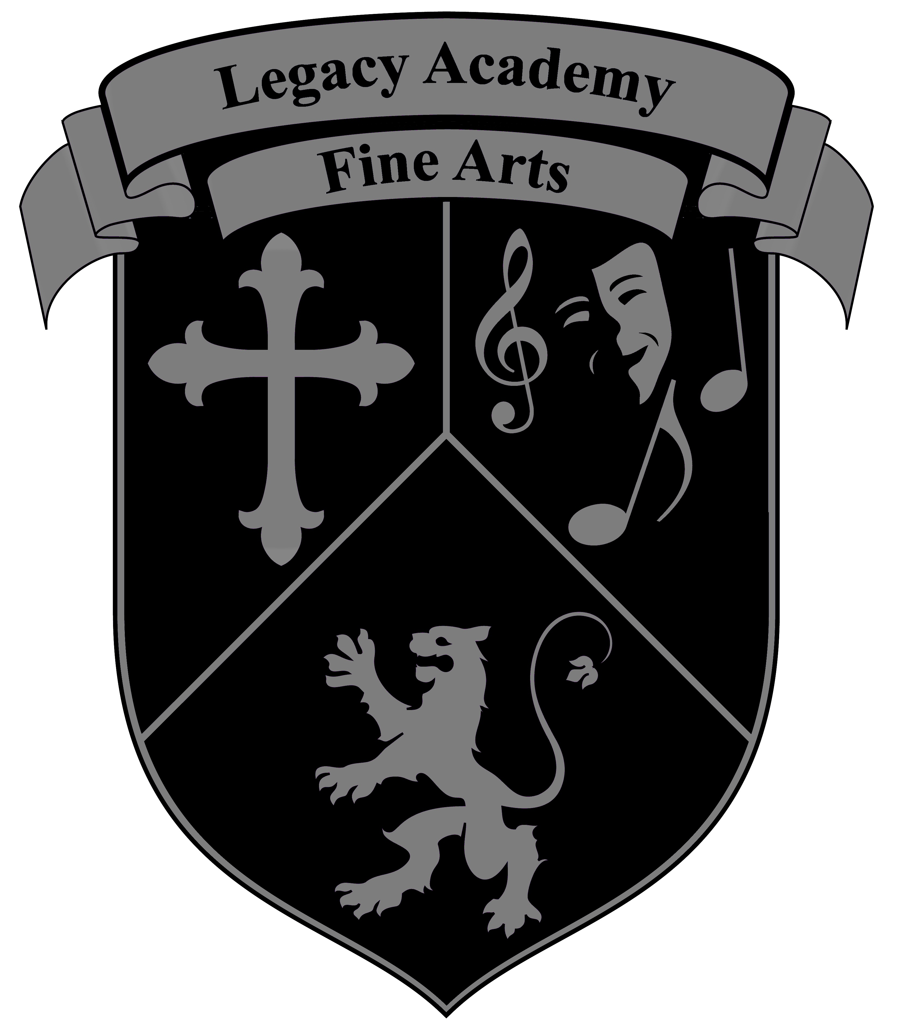
Fine Arts
2021-2022 Class Schedule
Guitar, Violin & Piano Mr. Pacheco (Music Room)
Monday | Tuesday | Wednesday | Thursday | Friday
 | 7:00-7:50 am  Intermediate/Adv.  Piano North Campus | 7:00-7:50 am  Intermediate/Adv.  Piano North Campus | 7:00-7:50 | 7:00-7:50
3:15-4:15  Beginning Violin Central Campus | 3:05-5:05  Intermediate  Violin/Orchestra  North Campus | 3:15-4:15  Beginning Violin Central Campus | 3:05-5:05  Intermediate  Guitar  North Campus | 1:00-3:00  Beginning Piano  North Campus  3:30-5:30  Beginning Piano  Central Campus
4:15-5:15  Beginning Guitar Central Campus |  | 4:15-5:15  Beginning Guitar Central Campus
Dance Ms. Felix
 | 3:15-5:15  Elementary Dance  Central Campus Room: TBA |  | 3:05-5:05  Int./Adv. Dance  North Campus
Art Ms. Gonzales
3:15-5:15  Beginning Art Drawing/Painting North Campus  Art Room | 3:15-5:15  Intermediate Art Drawing/Painting North Campus  Art Room | 3:15-5:15  Elementary Art  Drawing/Painting  Central Campus  Resource Room
Choir/Voice Mrs. Bethany
3:05-5:05 Mid/High Choir North Campus |  | 3:15-5:15 Elementary Choir Central Campus
Drums/Percussion Drumline Mr. Bethany and David Bethany
3:05-5:05 Mid/High Drums North Campus |  | 3:15-5:15 Elementary Drums Central Campus

Legacy Academy Fine Arts

Dear Parents and Students,
What sets a Christian School apart from a secular school in the study of music is the realization that music and celebration through sound is grounded in the Bible. Here at Legacy Academy, Christian music students will learn that their intellect and their talents come from the Creator, and that it should not be taken for granted. It is this commitment to Christian values coupled with a love of music that adds up to a harmonious combination.
Legacy Academy offers a multitude of opportunities to grow and learn in the field of fine arts. Music is a part of the daily curriculum at Legacy. After school music and fine arts classes in the following areas are offered for those interested in playing an Instrument or being involved in fine arts for Legacy Academy. Courses are yearlong activities.
- Instructor: Mr. Pacheco
Orchestra: Beginning, Intermediate & Advanced Violin, Viola, Cello & Bass (Class sizes: Min. 5 Max. 20)
- Instructor: Mr. Pacheco
Guitar and Electric Bass: Beginning, Intermediate and Advanced (Class sizes: Min. 5 Max. 25)
- Instructor: Mr. Pacheco
Beginning and Intermediate Piano (Class sizes: Min. 5 Max. 10)
- Instructor: Ms. Gonzales
Beginning & Intermediate/Advanced Art (Class sizes: Min. 5 Max. 10)
- Instructor: Ms. Felix
Beginning & Intermediate/Advanced Dance (Class sizes: Min. 5 Max. 10)
- Instructor: Mrs. Bethany
Choir: Elementary & Middle/High School (Class sizes: Min.10 Max. 30)
- Instructor: Mr. Bethany and David Bethany
Advanced Percussion (Drums) (Class sizes: Min. 10 Max. 20)
Costs: $160.00 per semester (billing through FACTS) Sign-up today at the Legacy Academy front desk.
2021-2022 Billing Dates:
- January 20, 2021 for $80
- February 9, 2021 for $80.
All other information and concert dates will be given when classes start! For private lessons or more information, please contact our Fine Arts Director at Rpacheco@legacyacademynm.com.
Thank You,

Mr. Pacheco
Fine Arts Director

