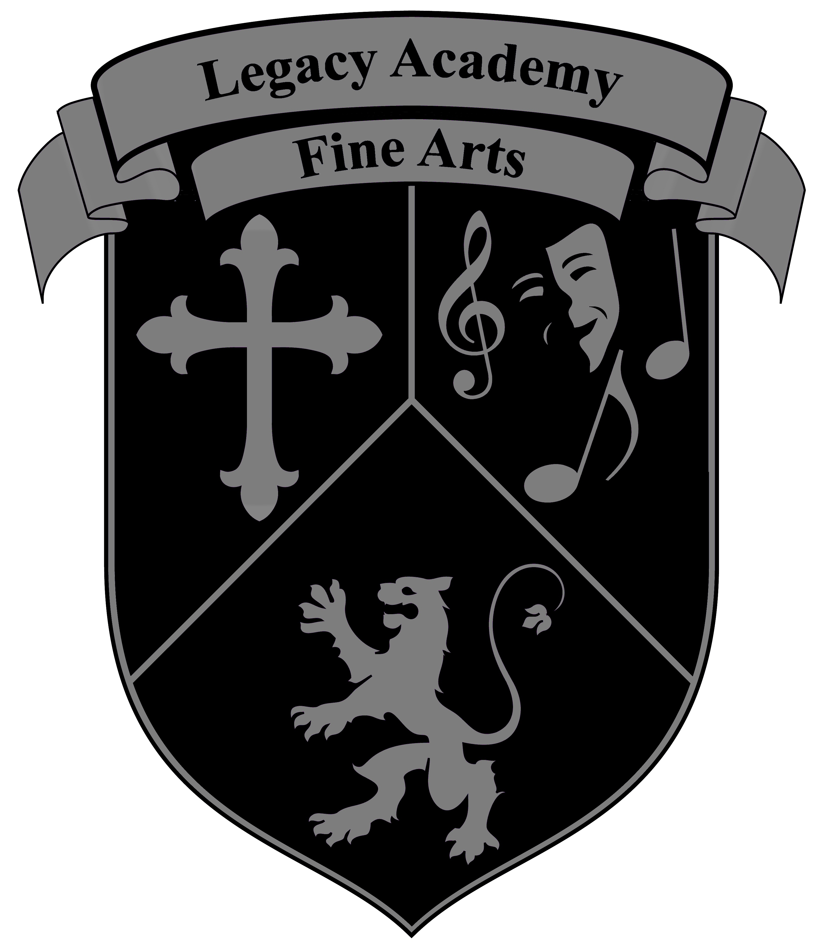
Legacy Academy Fine Arts

2021-2022 Class Schedule
Guitar, Violin & Piano: Mr. Pacheco (Music Room)
Monday | Tuesday | Wednesday | Thursday |  | Friday
 | 7:00-7:50  Intermediate/Adv.  Piano N. Campus | 7:00-7:50 | 7:00-7:50  Intermediate/Adv.  Piano North Campus |  | 7:00-7:50
3:00-4:00  Beginning Violin Central Campus | 3:05-5:00  Intermediate  Violin/Orchestra  North Campus | 3:00-4:00  Beginning Violin Central Campus | 3:05-5:00  Intermediate  Guitar  North Campus |  | 1:00-3:00  Beginning Piano  North Campus  3:30-5:30  Beginning Piano  Central Campus
4:00-5:00  Inter. Guitar Central Campus |  | 4:00-5:00  Beginning Guitar Central Campus
Dance: Ms. Felix
 | 3:35-5:35  Elementary Dance  Central Campus Room: TBA |  | 3:15-5:15  Int./Adv. Dance  North Campus Room: TBA
Art: Ms. Gonzales
3:15-5:15  Beginning Art Drawing/Painting North Campus Art Room | 3:15-5:15  Intermediate Art Drawing/Painting  North Campus Art Room | 3:30-5:30  Elementary Art  Drawing/Painting  Central Campus Art Room
Percussion/Drumline: To Be Announced
3:10-5:10  Advanced Drums  & Drum Line  North Campus  Drum Room |  | 3:15-5:15  Advanced Drums  & Drum Line  Central Campus  Drum Room
Choir/Voice: Pastor Kraig Shorter/Mr. Battke
 | 3:15-4:15  Mr. Battke  Elementary Choir  4:15-5:15  Mr. Battke  Beginning Guitar  Central Campus Music Room | Tuesday&Wednesday  3:15-4:15  Mr. Shorter  Inter. Choir  North Campus  Choir Room | 3:15-4:15  Mr. Battke  Elementary Choir  4:15-5:15  Mr. Battke  Beginning Guitar  Central Campus Music Room

