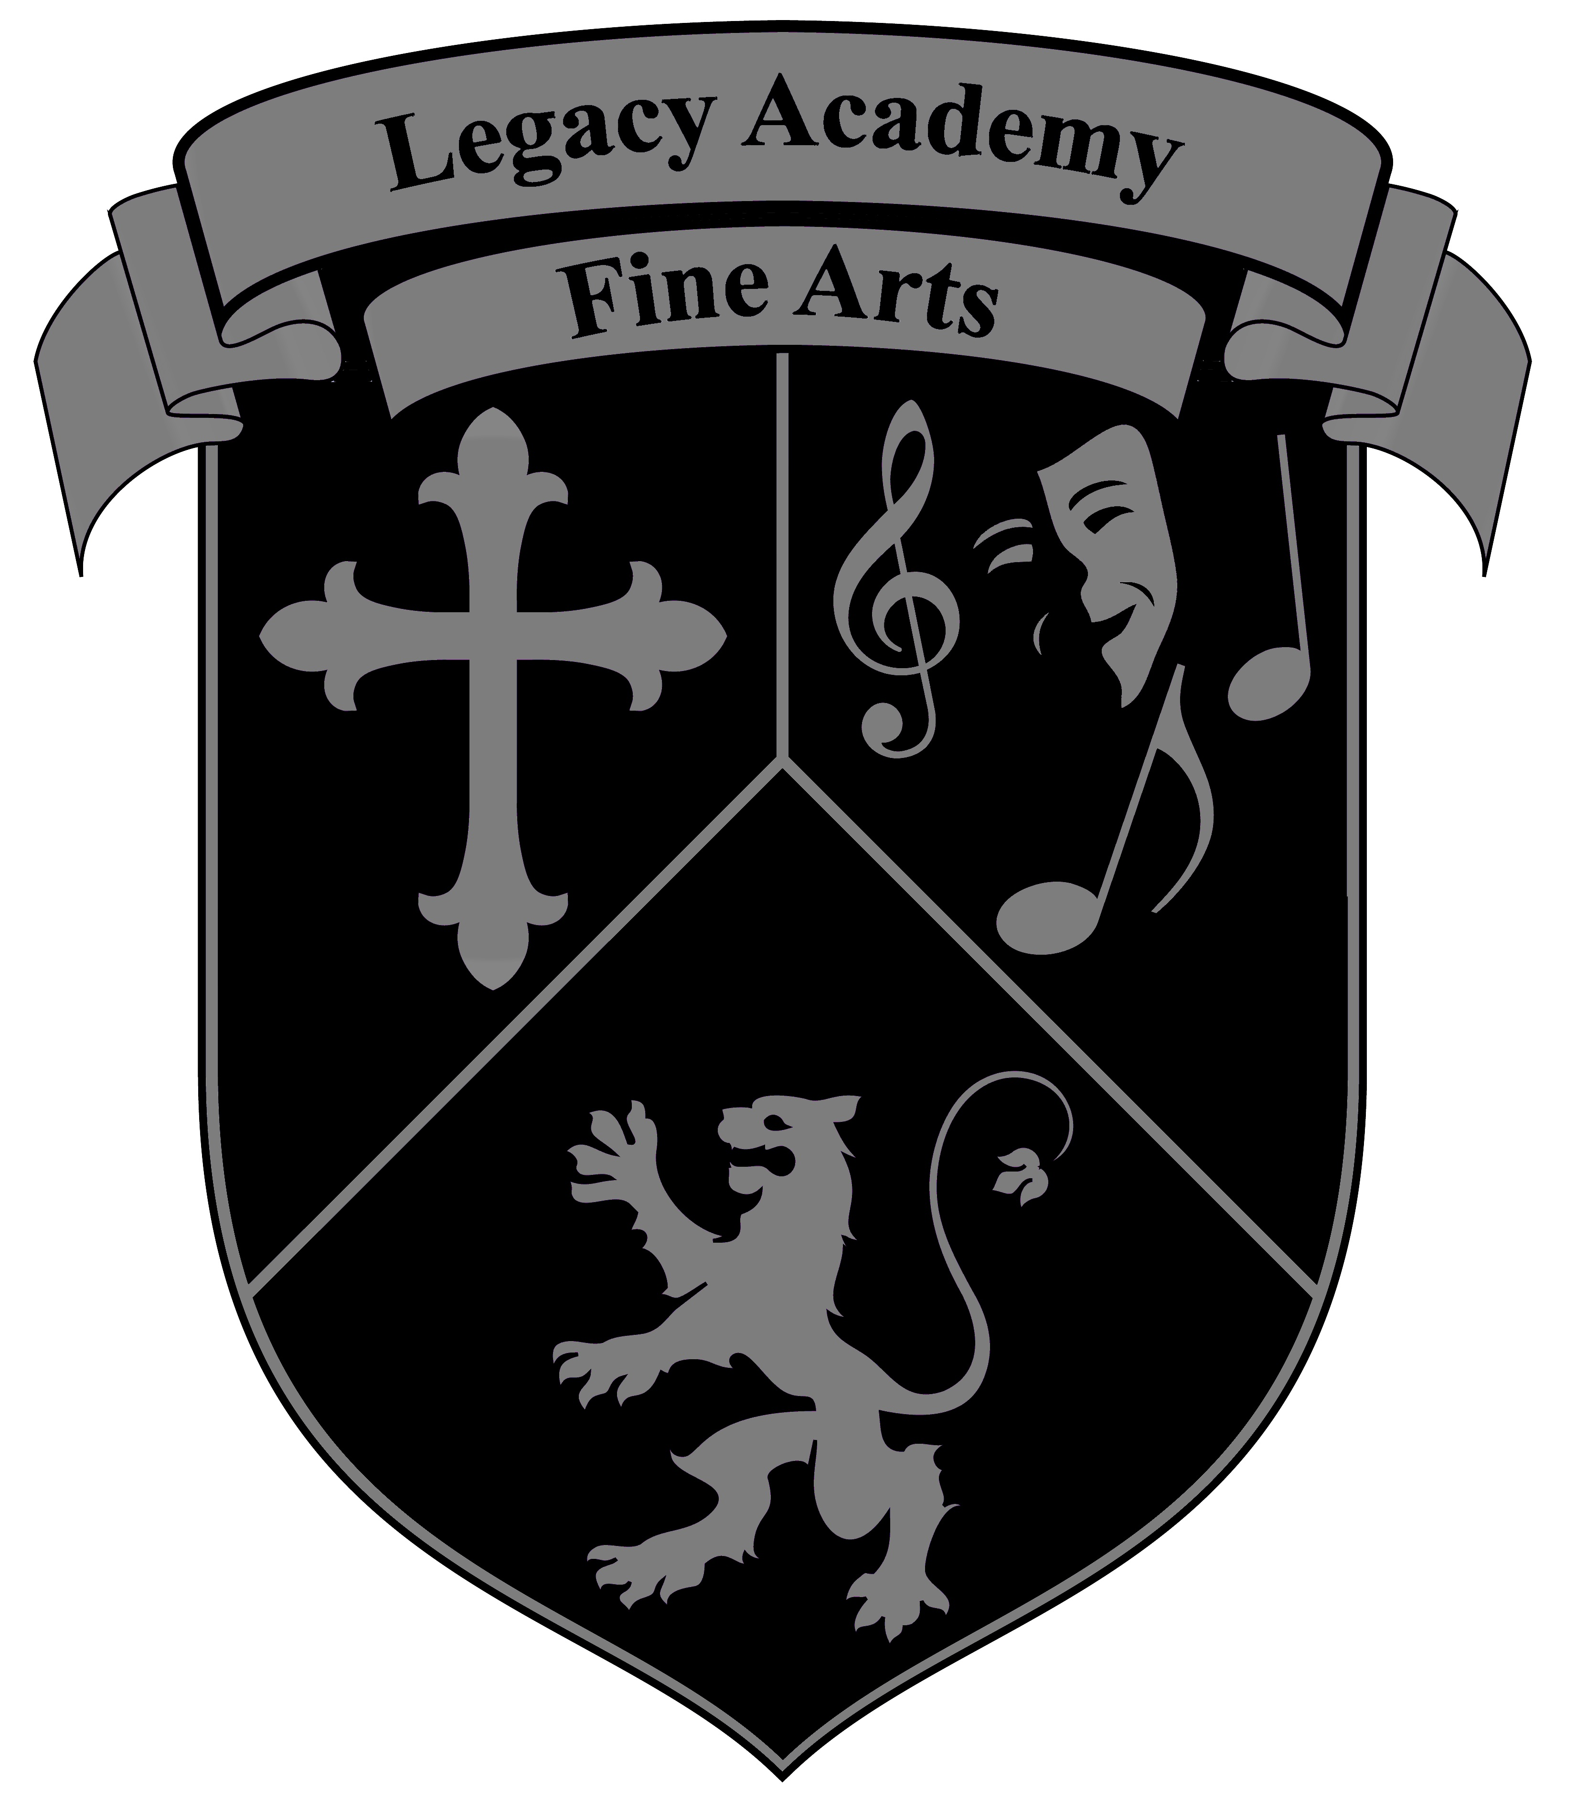
Legacy Academy Fine Arts

2022-2023 Class Schedule
Guitar, Violin & Piano: Mr. Pacheco (Music Room)
Monday | Tuesday | Wednesday | Thursday | Friday
 | 7:00-7:50  Intermediate/Adv.  Piano N. Campus |  | 7:00-7:50  Intermediate/Adv.  Piano North Campus
3:00-4:00  Beginning/Int. Guitar North Campus | 3:00-5:00  Intermediate  Violin/Orchestra  North Campus | 3:00-4:00  Beginning/Int. Guitar North Campus | 3:00-5:00  Beginning Piano  North Campus | 1:00-5:00  Private Lessons  North Campus
4:15-5:10  Intermediate. Guitar  Central Campus |  | 4:15-5:10  Intermediate. Guitar  Central Campus
Elementary Orchestra: Ms. Kentla
3:15-4:15  Beginning Orchestra  Central Campus |  | 3:15-4:15  Beginning Orchestra  Central Campus
Art: Ms. Gonzales
 | 3:15-5:15  Intermediate Art Drawing/Painting  North Campus Art Room | 3:30-5:30  Elementary Art  Drawing/Painting  Central Campus Art Room
Percussion/Drumline: TBA
Choir/Voice: Abigail Romero/ Beg. Choir & Guitar: Mr. Battke
3:10-4:10  Mrs. Romero  Inter/Adv. Choir  North Campus  Choir Room | 3:15-4:15  Mr. Battke  Elementary Choir  4:15-5:15  Mr. Battke  Beginning Guitar  Central Campus Music Room | 3:10-4:10  Mrs. Romero  Inter/Adv. Choir  North Campus  Choir Room | 3:15-4:15  Mr. Battke  Elementary Choir  4:15-5:15  Mr. Battke  Beginning Guitar  Central Campus Music Room | 3:15-5:15  Beginning Piano  Central Campus

Dear Parents and Students,
What sets a Christian School apart from a secular school in the study of music is the realization that music and celebration through sound is grounded in the Bible. Here at Legacy Academy, Christian music students will learn that their subjects and their talents come from the Creator, and that it should not be taken for granted. It is this commitment to Christian values coupled with a love of music that adds up to a harmonious combination.
Legacy Academy offers a multitude of opportunities to grow and learn in the field of fine arts. Music is a part of the daily curriculum at Legacy. After school music and fine arts classes in the following areas are offered to those interested in playing an Instrument or being involved in Fine Arts for Legacy Academy. Courses are yearlong activities.
- Instructor: Mr. Pacheco
Orchestra: Beginning, Intermediate & Advanced Violin, Viola, Cello & bass (Class sizes: Min. 5 Max. 20)
- Instructor: Mr. Pacheco
Guitar and Electric Bass: Beginning, Intermediate and Advanced (Class sizes: Min. 5 Max. 25)
- Instructor: Mr. Pacheco
Beginning and Intermediate Piano (Class sizes: Min. 5 Max. 10)
- Instructor: Ms. Gonzales
Beginning & Intermediate/Advanced Art (Class sizes: Min. 5 Max. 10)
- Instructor: Ms. Kentla
Elementary Orchestra: Violin, Viola and Cello (Class sizes: Min. 5 Max. 10)
- Instructor: To Be Announced
Advanced Percussion (Drums) (Class sizes: Min. 5, Max. 20)

- Instructor: Mr. Battke
Choir: Elementary/Guitar and Piano: Beginning

- Instructor: Abigail Romero
Choir: Middle/High School (Class sizes: Min. 5, Max. 30)
Costs: $180.00 per semester (billing through FACTS) sign-up today or at the Legacy Academy front Desk
2022-2023 Billing Dates: Please See Fine Arts Contract
All other information and concert dates will be given when classes start! For private lessons or more information, please contact Mr. Pacheco at Rpacheco@legacyacademynm.com Thank You, Mr. Pacheco Fine Arts Director

